Diagnostic Imaging Request Form – ULTRASOUND



ULTRASOUND Request Form



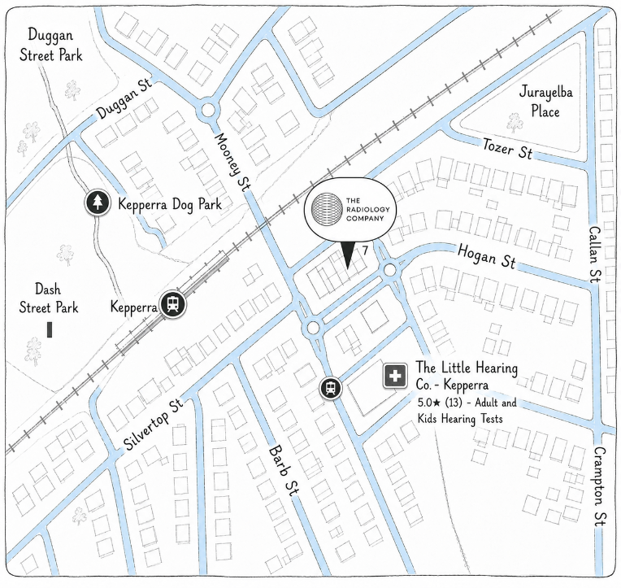


To Book your Ultrasound Online, or see information about our services, please scan the QR code or visit:
www.theradiologycompany.com
ULTRASOUND Request Form
How To Find Us:
QR - Google Maps Link (Above)
7 Dallas Parade, Keperra - 4054
(Basement Floor) – Free Street Parking Available
Bookings? Questions? Feedback?
hello@theradiologycompany.com
PH: (07) 2111 2800 FAX: (07) 3555 2535

We look forward to welcoming you!
Our Ultrasound Services will be available from 1st September 2026.
We will be additionally offering X-Ray, CT, DEXA Scans, Echocardiogram and Interventional procedures from November 2026.
ULTRASOUND WALK-IN SERVICES AVAILABLE
ULTRASOUND: Appendicitis, Deep Venous Thrombus (DVT), Ectopic Pregnancy, Arterial Occlusion, Testicular Infection (Orchitis/Epididymitis)- Testicular Torsion/Ovarian Torsion

